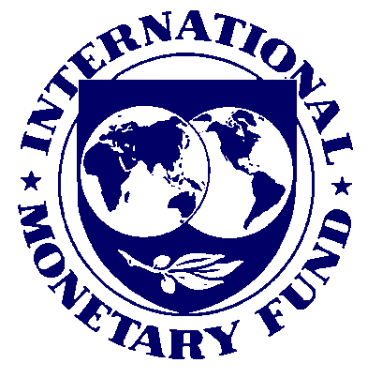
Press Release No. 11/77
FOR IMMEDIATE RELEASE
March 14, 2011

IMF Completes Third Review Under Stand-By Arrangement for Greece and
Approves €4.1 Billion Disbursement

The Executive Board of the International Monetary Fund (IMF) today completed the third review of Greece’s economic performance under a program supported by a three-year Stand-By Arrangement (SBA) for Greece. The completion of the review enables the immediate disbursement of an amount equivalent to SDR 3.6 billion (about €4.1 billion), bringing total Fund disbursements under the SBA to an amount equivalent to SDR 12.725 billion (about €14.6 billion).
The SBA, which was approved on May 9, 2010 (see Press Release No. 10/187), is part of a cooperative package of financing with Euro area member states amounting to €110 billion over three years. It entails exceptional access to IMF resources, amounting to more than 3,200 percent of Greece’s quota.
Greece’s economic program has made further progress toward its key objectives of putting the economy on a path of sustainable growth by boosting competitiveness, strengthening financial sector stability, and securing sustainable public finances. The underlying fiscal and broader reforms necessary to deliver the program’s medium-term objectives are gradually being put in place, although some major reforms still need to be designed and implemented to build a critical mass necessary to underpin fiscal sustainability and economic recovery.
Following the Executive Board's discussion, Mr. John Lipsky, First Deputy Managing Director and Acting Chair, said:
“Further progress has been made toward the economic program’s objectives. Output remains close to the targeted path, underlying inflation remains low, unit labor costs are falling, and significant fiscal adjustment is under way. Overall, a measure of stabilization has been achieved.
“Greater emphasis on underlying reforms will be needed during the period ahead. While the 2010 fiscal target was met, the strategy of under-executing the state budget to offset revenue shortfalls and overspending at subnational levels cannot be sustained.
“To help put the fiscal adjustment on a firmer foundation, it will be important to complete by May a medium-term budget strategy. Ensuring a fair distribution of the adjustment burden remains paramount, and the dialogue with social partners in this process is welcome. Implementation should begin during 2011 to address a projected budget gap. In parallel, the government should redouble efforts to combat tax evasion and control spending, especially at the local government level.
“To support the recovery, structural reforms need to be deepened. Legislation to liberalize regulated professions needs to be fully implemented, as do reforms pertaining to collective bargaining and the pension system. Important next steps include reducing administrative barriers to exports and formulating a strategy to unlock potential in the tourism sector.
“The government’s commitment to scale up its privatization and real estate development program is timely. More efficient use of state assets will support the fiscal adjustment efforts, promote growth and employment, and help Greece retire maturing debt.
“The financial system remains stable, and time will be provided to allow banks to deleverage and restructure in an orderly fashion. Capital support through the FSF remains available to viable banks if necessary.
“The authorities are to be commended for their commitment to this ambitious program, which will help Greece return to growth and prosperity,” Mr. Lipsky said.

